2017 Merit Badge University

Event Guide

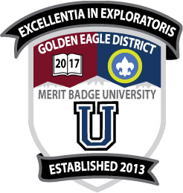

October 28, 2017

Suzanne Middle School
525 Suzanne Road
Walnut, CA 91789

Hosted By:
Golden Eagle District
Greater Los Angeles Area Council

Registration Deadline
October 25, 2017, 6:00p

Table of Contents
1 General Description 1
1.1 Merit Badge University (MBU) 1
1.2 Location 1
1.3 Schedule 2
2 Administration 2
2.1 Registration Fee 2
2.2 Maximum Capacity 2
2.3 Merit Badge Class Assignments 2
2.4 How To Register 2
2.5 The MBU Registration Form 3
2.6 How to Submit Registration 3
2.7 Late Registration 3
3 Requirements 3
4 Blue Cards 4
5 Program 4
5.1 Preparation 4
5.2 Pre-requisites or Post-requisites 4
5.3 Partial Completion 5
6 Conduct and Discipline 6
7 Uniforms 6
8 Snacks and Lunch 6
9 Health, Safety, and First Aid 6
10 Lost and Found 6

1 General Description

1.1 Merit Badge University (MBU)
The Merit Badge University (MBU) is an advancement opportunity that is open to any registered Boy Scout, Varsity Scout, Venturer, or Sea Scout. The event is hosted by the Golden Eagle District of the Greater Los Angeles Area Council (GLAAC).
Questions by parents should first go to Scoutmasters. Scoutmasters having questions should contact or email the event organizer below:
Golden Eagle District Chair
Martin Cardenas
mcardenas@goldeneagledistrict.org
909-261-2840 cell

1.2 Location
The location for MBU will be:
Suzanne Middle School
525 Suzanne Rd
Walnut, CA 91789

The Walnut Valley School District administration has been very generous by providing their facilities, but they are not the host of MBU and the school staff will not be able to answer any questions regarding MBU.
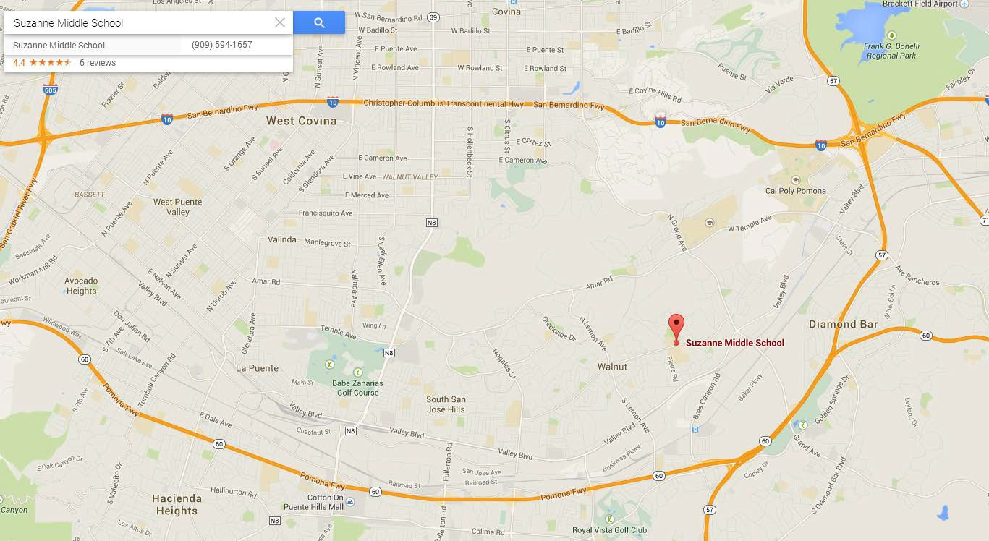
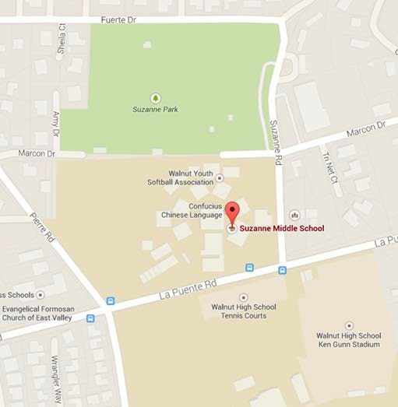
Please do not call Suzanne Middle School!

1.3 Schedule
9:30a | Start of Registration for Morning Session  (those attending an afternoon session will also be checked-in at this time)
10:00 – 11:55a | Morning Session
12:00 noon | Lunch Break
12:30p | Start of Registration for Afternoon session  (for those that did not attend a morning session)
1:00 – 2:55p | Afternoon Session

2 Administration

2.1 Registration Fee
The fee for attending classes at MBU is $15.00 for each Scout for the whole day, regardless of the number of merit badges being taken. The fee includes an event patch, similar to that shown on the cover page of this guide.
An optional lunch will be available for $5.00 (hot dog, chips, drink). Scouts are also welcome to bring a sack lunch.

2.2 Maximum Capacity
Most merit badge classes will be limited to 15 Scouts, but some may be limited to as few as 5.
In order to ensure the quality of instruction, we reserve the right to limit the total attendance of the event. If the limit is reached before the deadline, then registration will close and no more applications will be accepted.

2.3 Merit Badge Class Assignments
Scouts are assigned to merit badges in accordance with their preferences indicated on the MBU Registration Form. If a Scout’s first choice is already filled then he will be assigned his second choice. Scouts may be contacted in order to resolve any scheduling conflicts.
Class sizes are limited and students are given preference in the order that their registration is received.

2.4 How To Register
- Fill out application form.
- Select desired morning and afternoon merit badges.
- Pick 1st and 2nd choice for morning class.
- Pick 1st and 2nd choice for afternoon class.
- Email the application form to the event coordinator (shown in Section 1.1). Contact the event coordinator by phone for any issues requiring special consideration.
- Merit Badge assignment will be available upon event check-in.
Note:
Architecture, Composite Materials, and Fire Safety will require both sessions to complete the one merit badge. Scouts signed up in any of those merit badges will not have the option of a second merit badge.

2.5 The MBU Registration Form
General Instructions
- Please fill out the form completely, leaving no blanks.
- Since handwriting is often mistaken, typed or carefully printed information is desired.
Scoutmaster’s Requirements
- The Scoutmaster must provide a blue card (Merit Badge Application).
- The Scoutmaster should exercise judgment when authorizing his Scouts to take merit badges. Authorization indicates that the merit badge is age-appropriate for the Scout and that they will be able to participate in the class without disrupting the other Scouts.
Parent (or Guardian) Requirements
- In case of emergency, every effort will be made to contact parents (or legal guardian). In the event they cannot be reached, the signature gives permission to a licensed physician or emergency responder to secure proper treatment, including hospitalization, anesthesia, surgery, or injections of medication for the Scout.
- The Scout’s parents (or legal guardian) agree to pick up their son promptly as soon as they have been dismissed. NO LATE PICK-UPS PLEASE!
Emergency Information
- Emergency phone numbers given must be valid on the day of MBU
- If a Scout requires help with medications that he needs to take while at MBU, please provide instructions on the application. The MBU Health and Safety Staff will not administer any treatments unless specified in the application and supplied by the Scout.
- If a Scout has any other special needs, please provide instructions.

2.6 How to Submit Registration
Completed registration forms will only be accepted via email to the District Advancement Chair (contact information is shown in Section 1.1 of this guide). If emailing the registration form presents a hardship, please call the District Chair, instead of emailing.
The registration fee, and any associated material fees, will be collected upon check-in.

2.7 Late Registration
Pending space availability, walk-in registrations may be accepted, but cannot be assured.

3 Requirements
MERIT BADGE PAMPHLETS ARE NOT AVAILABLE AT MBU. Those Scouts starting and completing any badges at MBU must use the most recent Merit Badge requirements in effect.

4 Blue Cards
Blue Cards (Merit Badge Application, BSA Form #34124), are required. Blue cards must be filled out properly by Scout and signed by the Scoutmaster (or unit leader) when the Scout arrives for MBU.
The Blue Card (Merit Badge Application) is the official record of the Scout’s progress on the merit badge. Scouts are required to submit their completed and signed blue card to the counselor at the beginning of each class.

5 Program

5.1 Preparation
Merit Badge University should not be considered another “school” where pupils sit and stare for hours. Each Scout should have read his merit badge pamphlet and come prepared to answer each requirement.
Scouts are highly encouraged to print the worksheets available at http://www.meritbadge.org/wiki/index.php/Merit_Badge_W orksheets and fill out the answers. Scouts should be ready to take notes and come prepared with a notebook with blank paper and a pencil.

5.2 Pre-requisites or Post-requisites
Several merit badges will require preparation or follow up work.
It is ideal for a scout to complete the requirements before MBU. They should therefore begin work on those requirements immediately. For those that are able to complete the requirements in advance of MBU, there is a high probability of being able to complete the full requirements the day of MBU.
Merit Badge | Requirements to be completed either before or after MBU
Architecture
(requirements)
Aviation  (requirements) | - Requirement #2 (any two, but 2e and 2f are easiest to complete before MBU.)  - Requirement #4(any one)  - Visit an airport (local airports include El Monte Airport, Brackett Airport, Chino Airport). Take a picture of the airport and share at MBU  - Visit FAA facility (needs to be scheduled well in advance)  - Visit an aviation museum or attend an air show (local aviation museums include Chino Airport (Planes of Fame), Santa Monica Airport (Museum of Flying), LAX Airport (Flight Path Learning Center), California Science Center - Los Angeles (Air & Space Museum)
Composite Materials  (requirements) | - Minimum age is 14 years old or 9th grade  - Requirement 1a, 1b, 1c  - Requirement 4b  - Requirement 6
Digital Technology  (requirements) | - Current CyberChip
Disability Awareness  (requirements) | - Scouts must be prepared to discuss the requirements from the merit badge booklet.  - Requirement #2. Visit an agency that works with people with physical, mental, emotional, or educational disabilities. Collect and read information about the agency’s activities. Learn about opportunities its members have for training, employment, and education. Discuss what you have learned with your counselor.  - Requirement #3 Do TWO of the following: 3a, 3 b, 3c, 3d, 3e  - Requirement #4 - Do EITHER option A or option B:  - Requirement #5. Explain what advocacy is. Do ONE of the following advocacy activities:5a or 5b (8 hours volunteer service) or 5c  - Requirement #6. Refer to Merit badge Pamphlet  - Requirement #7. Refer to Merit badge Pamphlet
Electronics  (requirements) | - Requirement #1  - Requirement #2  - Requirement #6
Fire Safety  (requirements) | - Requirement 6  - Requirement 7d  - Requirement 10b and 10c  - Requirement 11  - Requirement 12 (research and prepare to discuss)
Geocaching  (requirements) | - Bring own GPS unit, know how to use it.  - Requirement #5c  - Requirement #7 - Bring a printout from www.geocaching.com showing a listing of the geocaches in your area. At least one of them must show the log entry for your find.  - Requirement #8 a, b, c, d (do one) – bring sufficient proof (printouts, etc)  - Requirement #9: Bring materials and share experience (can be done after MBU)

All other requirements not listed above will be covered in each session. However, Scouts are encouraged, as much as possible, to look ahead and to prepare as much as they can in advance of the MBU.

5.3 Partial Completion
If a Scout is unable to complete his merit badge, the “PARTIAL” completion will be noted on his Merit Badge Application, which will be returned to the Scout. The counselor will retain a copy for their records.
The Scout is responsible for completing his requirements for the merit badge.
The merit badge counselor has the authority to approve or disapprove of prior work done. In the event of a partial completion the scout can continue to work with the counselor after the MBU. The MBU Counselors will be available to certify any work completed after the event. However, the Scout will be responsible for making arrangements with the Counselor. In order to satisfy Youth Protection standards after the event, remember that a Scout is required to be accompanied by a buddy when meeting with the Counselor.

6 Conduct and Discipline
As a participant of the Merit Badge University, everyone promises to:
- Observe the Scout Oath (or Promise) and the Scout Law.
- Wear the official uniform when requested.
- Attend the classes as assigned.
- Be personally responsible for breakage, damage, or loss of property.
- Be courteous to other Scouts, counselors, and staff.
- Clean up each classroom at the end of each session.
- Clean up personal trash after eating.

7 Uniforms
Scouts should wear the official field uniform for MBU. Most units call this a “Class A” uniform. The uniform you normally wear to a troop meeting will be fine.

8 Snacks and Lunch
- All food must be consumed in the designated food area.
- Scouts are expected to clean up after themselves.

9 Health, Safety, and First Aid
- Scouts should take their own medicine if needed during class.
- No running inside or outside the school.
- No roller blades, roller shoes, roller skates, or skateboards are allowed.
- No alcohol, illegal drugs, fireworks, firearms, slingshots, or anything else that might distract from the learning environment. No tobacco or coffee for Scouts.
- The First Aid station is at the Headquarters table.

10 Lost and Found
The MBU Lost and Found is located at the Headquarters table. The return of lost items after the end of MBU is not guaranteed, so be sure to check before you leave. Put your name on EVERYTHING: books, papers, lunch boxes, coats, hats – EVERYTHING.

Scout Registration (Print Legibly)

Name: | District | Council | Unit
Address
Email Phone

Class Selection - $15.00 for the full day (1 or 2 Merit Badges)

- Select your 1st and 2nd choice for the morning session by printing a 1 or 2 for the appropriate merit badge.
- Select your 1st and 2nd choice for afternoon session by printing a 1 or 2 for the appropriate merit badge.
- Pick a 1st and 2nd choice even if you only want one. Assignments are made on a first-come, first –served basis until classes are full.

Merit Badge | Selection |  |  | Pre-Requisites | Class/Material Fee
 | Morning  (10:00-12:00) |  | Afternoon  (1:00-3:00)
Architecture (requirements, worksheet)
*Note: This MB will require both sessions.
Aviation (requirements, worksheet) |  |  |  | See Section 5.2
Composite Materials (requirements, worksheet)  *Note: This MB will require both sessions. |  |  |  | See Section 5.2  Min 14 yrs old or 9th grade | $20 payable onsite to counselor (cash only)
Digital Technology (requirements, worksheet) |  | N/A |  | See Section 5.2
Disability Awareness (requirements, worksheet) |  |  |  | See Section 5.2
Electronics (requirements, worksheet) |  |  |  | See Section 5.2 | $20 for assembly kit,  Payable onsite to counselor (cash only)
Fire Safety (requirements, worksheet)  *Note: This MB will require both sessions. |  |  |  | See Section 5.2
Geocaching (requirements, worksheet) |  |  |  | See Section 5.2

Lunch (optional) - $5.00
Lunch (hot dog, chips, drink) will be available for purchase onsite.

I would like to purchase lunch: Yes No

Emergency Contact
Name (Should be a Parent/Guardian) | Relationship | Phone

Special Instruction
Please provide any special instructions in the space below

