Golden Eagle District

2019 Camporee

Event Guide for
Patrol and Unit Leaders
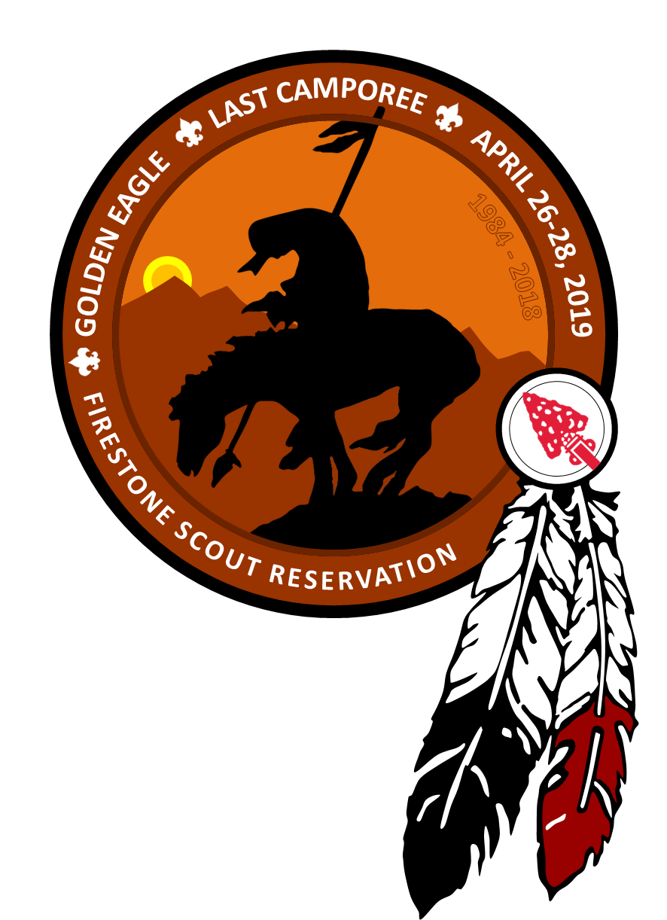

April 26-28, 2019

Firestone Scout Reservation
19001 Tonner Canyon Rd.
Brea, CA 92821

This Camporee will be conducted by
the Los Lobos Chapter of the Tuku’ut Lodge of the Order of the Arrow
and
the Troops and Crews
of the
Golden Eagle District
Greater Los Angeles Area Council

Table of Contents

EVENT INFORMATION 1
DIRECTIONS 1
PARTICIPATION 4
Boy Scouts 4
Webelos 4
REGISTRATION INFORMATION 4
Important Dates 4
Registration Fee 5
Late-Registration 5
Pre-Registration and Fast Pass Check 5
REQUIRED PAPERWORK 6
UNIFORM 7
GENERAL INFORMATION 7
Patrol Campsites 7
KYBOs 7
Patches 8
Lost and Found 8
Camporee Trading Post 8
ARRIVAL AND DEPARTURE INFORMATION 8
Arrival 8
Check-in 9
Check-Out 9
COMPETITION GUIDELINES for PATROL LEADERS 10
EVENTS 11
Patrol Inspection Event 12
Campsite Inspection Event 12
SCORING 13
AWARDS 14
Event Ribbons (for Patrols) 14
Top Patrol 14
Spirit Stick (for Troops) 14
CODE OF CONDUCT 16
PATROL LEADER CHECK LIST 17
ORGANIZATION 18
FREE TIME 18
CAMPFIRE AND ORDER OF THE ARROW CALLOUT 18
CAMPOREE SCHEDULE 19
SUGGESTIONS: 20
For Unit leaders: 20
For Patrol Leaders: 20
CHECK IN/OUT FORM (BY PATROL LEADERS) 21
UNIT REGISTRATION FORM 22
ACTIVITY CONSENT FORM 23

EVENT INFORMATION
Overview

WHO: Approximately 300 Boy Scouts, Venturers, and Scouters (adults) from the Golden Eagle District in the Greater Los Angeles Area Council.

WHAT: A district-wide Camporee emphasizing Scout skills and fun.

WHEN: Friday, April 26, 2019 through Sunday, April 28, 2019
Check-in begins at 5 p.m. Check-out ends at 11 a.m.

WHERE: Firestone Scout Reservation
19001 Tonner Canyon Rd.
Brea, CA 92821

WHY: To develop scouting skills, foster brotherhood, and to increase the level of scouting activities in the Golden Eagle District.

HOW: This Event Guide contains many details about our Camporee. For additional information, please contact:

Ken Hirscht at khirscht@goldeneagledistrict.org

DIRECTIONS
Most units will likely be arriving from the 57 Fwy South

Directions:
Exit Brea Canyon Rd. and turn right (heading south).
Proceed to Tonner Canyon Rd. and turn left.
Just past the freeway is a manned security gate. The security guard should allow entry.
Proceed for about 1.0 mile to the Camporee entrance on the right. Look for the signs.

Note: Camporee will be held in a “new” campsite at Firestone. This new campsite is about 2/3 of a mile before the main entrance to Firestone.

Refer to the maps on the following pages.

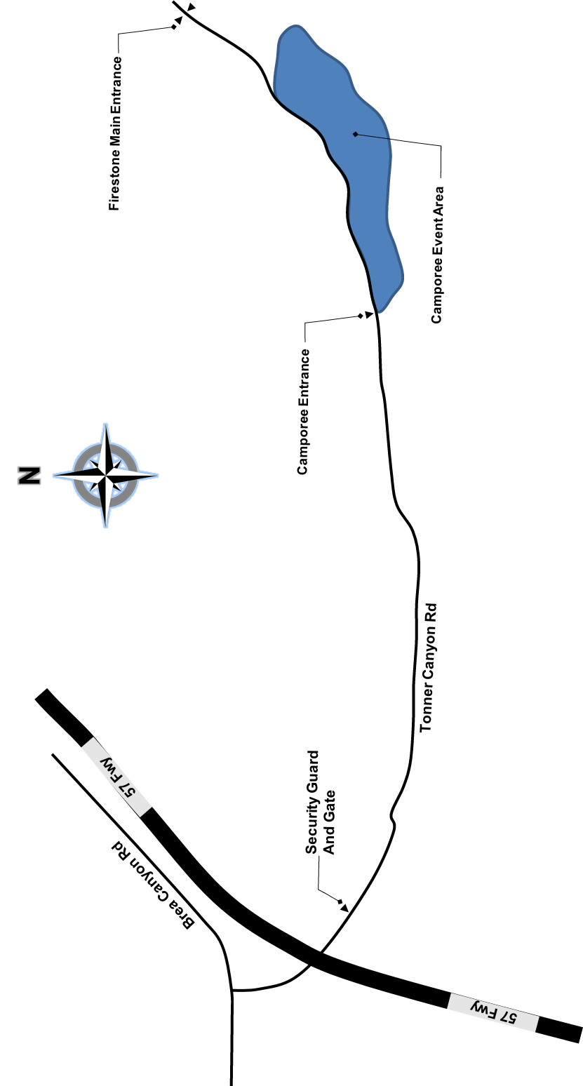

Directions to Firestone

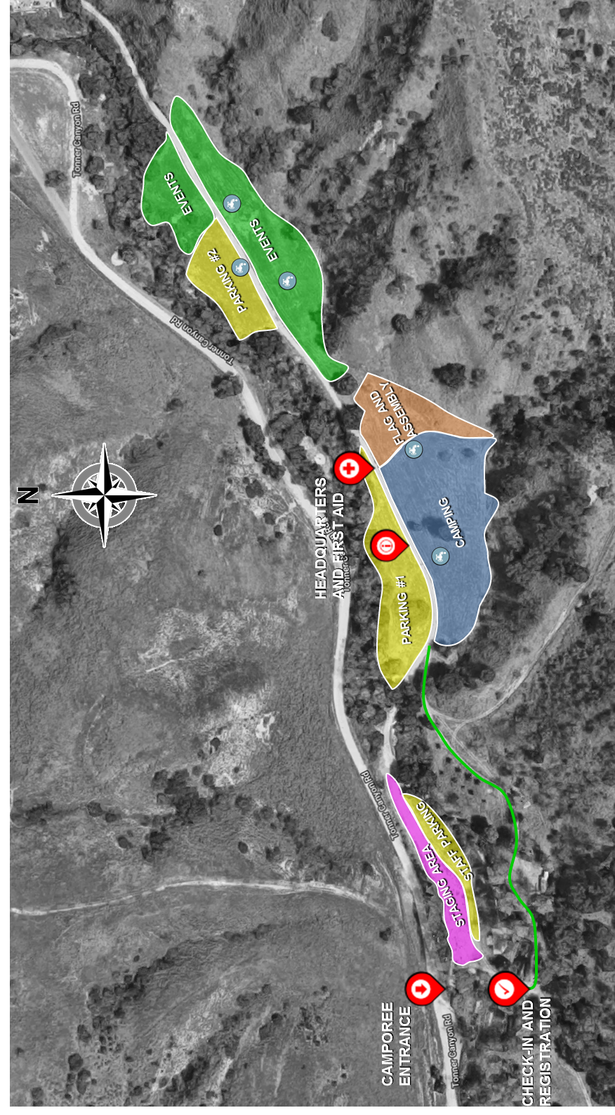
Camporee Area Detail

PARTICIPATION
This event is targeted mostly to Boy Scouts, however any interested Webelos dens are welcomed to participate as well.

Boy Scouts
Boy Scouts are expected to check-in on Friday, as a complete Patrol. Exceptions can be discussed for Patrols arriving early on Saturday, however all Boy Scouts are expected to pay the “normal” Camporee fee regardless of arrival. See registration information below.
All attending units must take responsibility for ensuring that their Adults have current Youth Protection Training, within the previous year, as well as ensuring that the necessary qualified supervision levels are met.

Webelos
Webelos have the option to visit for the day or to camp for the weekend. Campers will pay the “normal” Camporee fee. Day-visitors can pay a reduced day fee. See registration information below.
In addition to the necessary Youth Protection Training requirements, Webelos dens must ensure that at least one Adult is BALOO-trained. It is the responsibility of the den leadersip to ensure that these requirements are met.

REGISTRATION INFORMATION

Important Dates
- Through April 11, 2019 at 6:00p: Online registration at “normal” fee
- April 11 at 6:01p – April 25 at 11:59p: Late Registration (late fee applies)
- April 11 at 7:00p at St. Matthews United Methodist Church:
  - Orientation/Information Meeting. A representative from every unit attending Camporee should be present at the orientation meeting.
  - Pre-Registration and Fast Pass Check
- April 25 at 11:59pm: Registration closes.

Registration Fee
The cost is $20.00 per person through April 11, 2019. Register online at www.goldeneagledistrict.org

The cost for all day-visitors (not camping) is $6.00 per person. All daytime attendees must still pre-register. Day-visitors must check in at the Headquarters area. Campfire visitors should not arrive before 6:30p.

Late-Registration
All registrations from April 11, 2019 through April 25, 2019 are on a space-available basis and must be made online. A late fee of $5.00 per person will be applied to these reservations.

After April 25, 2019 at 11:59p, no registrations will be accepted!

For additional information regarding registration, please contact Martin Cardenas at mcardenas@goldeneagledistrict.org

Pre-Registration and Fast Pass Check
Those that pre-register will be given a “Fast Pass” ticket which will streamline check-in at the event.

Pre-registration is on April 11th at St. Matthews United Methodist Church in Hacienda Heights (site of the previous GE monthly Roundtable). All required materials and payment must be received by that date.

In order to make use of the “Fast Pass” at the event, all members of the Patrol must be present and ready in order to be admitted. NO EXCEPTIONS.
NOTE: Bonus points will be given for those units that take advantage of Fast Pass. At the discretion of the Camporee staff, additional points may be given if the required materials are turned-in by the actual Patrol Leader.
See the section in this document regarding Scoring

REQUIRED PAPERWORK
Patrol Leader:

- Three (3) copies of the completed Check-in/Check-out form (Patrol Roster) found in this packet (Patrol roster – page 21 in this guide)

- Activity Consent Form for each Patrol member.

DOWNLOAD:
https://filestore.scouting.org/filestore/pdf/19-673.pdf

- Two (2) Copies of Annual Health and Medical Form for each Patrol member.
      - 1st copy: To be carried by the Scout during the entire event.
      - 2nd copy: To be handed in by the Patrol Leader at check-in. This will be returned at check-out.

DOWNLOAD:
https://filestore.scouting.org/filestore/HealthSafety/pdf/680-001_AB.pdf

If anyone does not have a medical/health records form, the unit leader will be asked to obtain one immediately. If one cannot be obtained immediately, then the Scout must return home until the medical/health records form is obtained.

Unit Leaders:

- A copy of the Unit Registration form (page 22 in this guide)
- Registration receipt to verify payment, if necessary.

Most of the required forms are contained in this packet or may also be downloaded online at: www.goldeneagledistrict.org

Medical forms are not included in this guide. Please download from the link above.

UNIFORM
Scouts are REQUIRED to wear the “FULL OFFICIAL UNIFORM” (Field Uniform) during the following activities:

- Transportation to and from Camporee
- Check in and out
- Patrol Inspection
- Dinners
- Flag ceremony
- Campfire
- Scout’s Own

At all other times, Scouts are encouraged to wear the Activities Uniform.

Scouts should take pride in the image they project as a uniformed Boy Scout. Accordingly, the quality of uniforming will be an important aspect of the Patrol Inspection.

GENERAL INFORMATION

Patrol Campsites
To the extent practicable, patrols from the same troop will be assigned non-adjacent campsites to separate them from one another. Separation ensures that each patrol is judged on its own merit.

Charcoal fires may not be used in the patrol campsite. Food containers should be kept safely above ground.

Each patrol will be assigned a campsite. Prepare for camp sites no larger than 20’ x 30’. There will be no tables in the campsites nor will there be shade, therefore it is strongly recommended that these be brought in order to make the weekend a pleasurable one.

There are no trash receptacles. All units must plan to bag their trash and take it home for proper disposal.

KYBOs
Portable restrooms (KYBOs) will be placed throughout the Camporee area. Although all KYBOs will be clean and well-stocked at the beginning of Camporee, everyone is advised to bring extra toilet paper; just in case.

It is everyone’s responsibility to ensure the cleanliness of the KYBOs for the entire weekend.

Patches
Participation patches will be issued to the Patrol Leader after the patrol checkout sheet is signed by a member of the Camporee check-out staff. The unit leader should make arrangements with their Patrol Leadership to present the patches to participants at a later time.

Lost and Found
The Headquarters area will have all lost and found items. After Camporee, all unclaimed items will be retained by the Camporee Chair, Mr. Ken Hirscht (khirscht@goldeneagledistrict.org) for 10 days. After 10 days, any remaining items will either be discarded or donated to charity.

Camporee Trading Post
Saturday, April 27, 2019 from 12:00 p.m. until 5:00 pm - hours subject to change. Snacks and other items will be available for purchase.

ARRIVAL AND DEPARTURE INFORMATION

Arrival
Because of the overwhelming number of vehicles that converge on Camporee at about the same time, there will a slightly new procedure for vehicles. As needed, vehicles will be stopped at a “staging area” before being allowed to enter the Camporee area.

In addition to this procedure, all Units are asked to consolidate vehicles as much as possible. Single drivers (only one youth per vehicle) will be asked to unload in a designated area outside of the Camporee entrance and the Youth will be asked to walk in.

Once vehicles are allowed to enter the Camporee area, those vehicles that are transporting only (not staying) should plan to unload quickly and then exit. Units transporting gear will be asked to park in designated parking spaces.

Equipment trailers are permitted and will be assigned to a designated parking area.

Motor Homes and Recreational Vehicles (RVs) should be left at home.

Check-in
Check-in is Friday, April 26, 2019 from 5:00 p.m. to 8:00 p.m.

VERY IMPORTANT: Every member of the patrol must be present in order for the Patrol to check-in. NO EXCEPTIONS.

At check-in, the Patrol Leader is to hand in either the required paperwork (page 4) or the Fast Pass form that shows that all paperwork has already been submitted.

Check-Out
Early checkout for units needing to leave on Saturday will take place immediately after the campfire. Contact Headquarters for further instructions.

All Units should leave before 11:00 a.m., Sunday, April 28, 2019. Please make sure that transportation arrangements have been made in advance.

In keeping with “Leave No Trace”, we expect each unit to leave their campsite clean, or cleaner, than it was.

A Unit representative must be present to pick up patches at the time of checkout.

COMPETITION GUIDELINES for PATROL LEADERS
Every patrol will be competing with other patrols, from other troops as well as from their own troop too.

Patrol Leaders will want to make sure that all patrol members know their basic scouting skills. In order to help patrols be prepared, units should consider scheduling a pre-Camporee outing to teach, test, and prepare the patrol.

EAGLE SCOUTS WILL NOT BE ALLOWED TO COMPETE. It is recommended that senior patrols, predominantly made up of Eagle Scouts, contact the Camporee Chairman to express interest in participation on staff.

The structure of the events will be the same as past Camporees. Each event will contain a skill component as well as an element of sportsmanship. Each troop within Golden Eagle District is asked to participate in organizing an event. Unit leaders should contact James Muñoz at jmunoz@goldeneagledistrict.org to sign up to host an event.

EVENTS
- Uniform Inspection
- Fire Building
- First Aid
- Knots
- Scout Golf (Scout History)
- Flag Etiquette
- Knife & Ax Safety
- Campsite Inspection
- Orienteering
- Lashings
- Physical Fitness
** All events will be timed!

This is a competition. Patrols will be judged on their knowledge and performance in common scouting knowledge and tasks. No BSA Handbooks or cell phones will be allowed in the event area.

In addition to the skills event noted above, each patrol will also participate in a Patrol Inspection (at check-in) and a Campsite Inspection on Saturday. See below for additional information.

It is usually not possible to complete all skills events before lunch. Everyone should plan to prepare an easy quick lunch, or have a pre-bagged lunch, and then continue with the skills stations until the competition ends.

Note that although Patrols may participate in all events, scores from any event hosted by their own troop will not count in the final score calculations. Because of this, it is acceptable for Patrols to skip an event hosted by their troop. For Patrols that do not have a troop hosting an event, one score, chosen at random by the judges, will be eliminated from the final score calculations.

Patrol Inspection Event
Patrol Inspection includes two major ideals of scouting: Uniform Wear and Being Prepared (i.e. having the “Ten Essentials”).

Each member should be prepared to present themselves in full Scout uniform, with patches properly affixed, in the correct location, and all position patches accurately reflecting current status. While some flexibility may be accepted, maximum points will be awarded for maximum uniformity.

Each member of the patrol must carry their “Ten Essentials” at all times.

Patrol Inspection will be scored, and that score will contribute to all scoring calculations, however, there will be no ribbons presented for this event.

Campsite Inspection Event
After breakfast and before lunch, each patrol campsite will be inspected for safety and neatness. Patrols are not to be in their campsites after breakfast and before lunch. Campsite Inspection criteria will include, but is not limited to:
- Patrol Duty Roster, Menu, Neat Map of Patrol campsite and area, Fireguard Chart, Safety Postings (tripping hazards, etc.) and placement
- Cleanliness and Organization. Use of campsite space and removal of trash.
- Gateway OR Camp Gadget of the Patrol’s own design.
- Proper storage for food and Patrol cooking/eating items.
- Visual inspection of each tent interior. Prior to leaving the campsite, the outer door of each tent should be open and tied so that inside is visually accessible from exterior of tent. Patrols not following this instruction will be downgraded on tent inspection.

All members of the patrol must leave their personal mess kit (eating kit) and personal cleaning kit in their Patrol’s central storage. This will prevent any animals from entering tents. Make note on the patrol storage where these items are being stored and can be found so that the inspectors can grade appropriately.

Campsite Inspection will be scored, and that score will contribute to all scoring calculations, however, there will be no ribbons presented for this event.

SCORING
Each Patrol will receive points for each event in which they participate. The points issued at each station are based on the scoring system employed by the troop hosting each station. Any disputes should be resolved by the skill station coordinator. Except for personal emergencies, the Headquarters area will be off limits to non-staff personnel during event scoring and evaluation.

Very importantly, Camporee is a place for everyone to demonstrate Scout Spirit at all times. Accordingly, Patrols may be issued bonus points or deductions based on Scout Spirit, or lack thereof.

ABOUT SPIRIT POINTS: The Camporee staff and commissioners are authorized to issue bonus points and/or deductions for Spirit, or lack thereof, based on their observations of the Scouts and Patrols throughout the day on Saturday.

Bonus Points: Any notable actions that clearly and obviously exemplify Scout Spirt will result in bonus points.

Deductions: Reasons for deductions may include, but are not limited to:
- Any issues that run counter to the Scout Oath and Law, whether by Adults or Scouts, such as offensive behavior and/or language.
- Lack of cooperation
- Lack of cleanliness
- Adults interacting with the Scouts and Patrols, or in the Scout campsites

Deductions will be levied for each occurrence. The actual point deduction will be determined by the severity and/or repetition of the infraction.

AWARDS
There are three different types of awards that will be presented.

Event Ribbons (for Patrols)
The top patrols for every event station will be determined solely on the raw score for each event. Every event will recognize the top scoring patrols and will present the following ribbons:
- Presidential
- First Place
- Second Place
- Third Place

As previously noted, the Patrol Inspection and Campsite Inspection events will not present ribbons.

Top Patrol
Every patrol is automatically competing for overall Top Patrol of Camporee.

The top Patrols are determined based on the accumulated points for all event stations PLUS any accumulated “Spirit” points/deductions.

The top Patrols will be presented with the following ribbons.
- Presidential
- First Place
- Second Place
- Third Place

The Top Patrol will be the one that scored the highest point in the most skills events and has shown the most Scout Spirit.

Spirit Stick (for Troops)
The Spirit Stick will be awarded to the “best” Troop at Camporee. The determination of the best Troop is determined by the performance of their competing Patrols (ribbons earned as well their demonstration of Scout Spirit at Camporee.

The Sprit Stick scoring uses the ribbons earned by each Patrol, using a weighted system that attempts to balance the importance of the ribbon(s) earned (Presidential is higher than First, and so on) against the number of ribbons earned. To this weighted earned-ribbon system, all associated bonuses and deductions for every Patrol in the Troop will adjust the final Troop point total

There can be only one Troop that earns the Spirit Stick!

ABOUT RIBBON-WEIGHTING:

The following is offered as a simplified explanation of the ribbon-weighting point system used in determining the Troop that wins the Spirit Stick.

For demonstration purposes, the following assumptions are set:
- Each troop has only one patrol in attendance.
- No bonuses or deductions were issued to anyone.
- The ribbon weighting is as follows:
- Presidential: 10 points
- First Place: 7 points
- Second Place: 5 points
- Third Place: 3 points

Given the assumptions above, the following situations could result:
- If Troop “A” received only one Presidential ribbon (10 total points), and Troop “B” received 2 First Place ribbons (14 total points), Troop “B” would have a higher point total.
- If Troop “A” received only one Presidential ribbon (10 total points), and Troop “C” received 3 Third Place ribbons (9 total points), Troop “A” would have a higher point total than Troop “C”, despite Troop “C” having earned three times the number of ribbons.

VERY IMPORTANT: The Camporee Staff reserves the right to use a different weighting system than that shown above, which may, or may not, alter the details of the actual calculations and may produce a different result than that shown above.

For simplification purposes, the above example eliminated Scout Spirit from discussion. However everyone should note that Scout Spirit can, and will, be an important factor in overall scoring.

CODE OF CONDUCT
Everyone’s personal conduct will do much to enhance the image of Scouting. Accordingly, we ask that everyone adhere to the following Code of Conduct.

- The Scout Oath will be the guide throughout the Camporee.
- Set a good example by being neatly dressed and presentable. The official field uniform will be worn when required. During designated events on Saturday, an “Activity uniform” may be worn.
- Attend all scheduled activities and take part in as many optional activities as able.
- In consideration of the other participants at the Camporee, everyone is to be in their tent and remain quiet from lights-out to reveille.
- Be responsible for keeping tents clean and neat, and adhere to all Camporee policies and regulations.
- Pledge to do their share to prevent littering and defacing of the Camporee site.
- Agree that no gambling of any kind is permitted.
- Understand that the illegal possession or use of drugs, alcohol, harmful substances, fireworks and firearms is strictly prohibited.
- Accept personal responsibility for any loss, breakage, or theft of property which may be caused.
- Campsite etiquette will be strictly enforced. Permission must be granted before entering another Patrol’s campsite. No one is permitted in other campsites when the campsite is unattended. Unit leaders will be informed of violations.

Violations of this Code of Conduct will result in points being deducted from the offending patrol. Violation of the Code of Conduct, by adults, will result in point deductions for the patrols associated with that Troop.

Remember, the theme for this year’s Camporee is

“NEW BEGINNING”

PATROL LEADER CHECK LIST

- Remind all patrol members to have their Medical Release Form on them and in a safe place. Make sure patrol members have their Ten Essentials.

- Be sure that all patrol members have read and understand the Code of Conduct and all the safety procedures for their own safety.

- Make sure all patrol members understand the agenda for the Camporee and the times for each event.

- Respect other patrols’ campsites and make sure all patrol items are marked with patrol name.

- All questions that are going to be asked will come out of the Boy Scout Handbook.

- Be sure to bring the patrol flag and take it to all events.

- Be sure that legible copies of the patrol duty roster, menu, fireguard chart, map and other information are fully completed and posted in an area that is easily located.

- Make sure that all the proper patches are attached to the proper uniform and on the correct location on the Scout shirt. Make sure all patrol members are wearing either pants or shorts - deductions will be taken at uniform inspection for patrol members not wearing the same uniform.

- Once all patrol members have read the whole packet, everyone should “Be Prepared” for this year’s Golden Eagle District Camporee.

- Remember, size of campsites may be as small as 20’ x 30’.
- Bring required paperwork (See page 6).

- It is suggested that patrol members wear a “troop” or “camp” t-shirt under their “Full Uniform” to the morning Flag Ceremony, so that the shirt may be removed for the Events Competition and Lunch.

ORGANIZATION
Each Patrol must be able to demonstrate what they are capable of accomplishing, based on their own merit.

To facilitate this, this Camporee will enforce a strict separation of Scouts in competing Patrols – Patrols from the same Troop will be separated. Adults will also not be permitted to interact (camp, eat, etc.) with Scouts in competing Patrols.

Other than coordinating gear drops, the competing patrols should have no contact with outside leadership from check-in to the completion of the competition events on Saturday.

During the competition period of Camporee, only Camporee commissioners will be allowed in patrol campsites.

All attending adults are encouraged to participate as Camporee staff when not conducting the event assigned to their unit.

FREE TIME
Following the completion events, there will be free time. Activities will be varied. We will also be having a Leadership Roundtable on information such as Youth Protection and other risk management topics. The Camporee Trading Post will also be open.

CAMPFIRE AND ORDER OF THE ARROW CALLOUT
The Campfire ceremony is open to everyone. Day-visitors are invited to come to the Campfire on Saturday night, subject to day use fees, but should not arrive before 6:30p.

Campfire formation will begin at 7:30 p.m. Saturday evening. Each patrol will be asked to participate with either a skit or song. If a unit would like to perform something special at the campfire, please contact Mike Wiesner at mwiesner@goldeneagledistrict.org.

At the Campfire, all awards will be presented. The Campfire will conclude with the Order of the Arrow Callout Ceremony for the recently-elected Scouts.

CAMPOREE SCHEDULE

FRIDAY April 26, 2019
Start End Activity
5:00 p.m. 8:00 p.m. Check-In/Inspection Event (Full Uniform)
6:00 p.m. 8:00 p.m. Dinner and Clean Up (Full Uniform during Dinner)
8:30 p.m. 9:00 p.m. Patrol Leader Meeting at Headquarters
9:30 p.m. 10:00 p.m. Staff Meeting at Headquarters
10:00 p.m. Lights Out – All quiet

SATURDAY April 27, 2019
Start End Activity
6:30 a.m. Reveille
6:30 a.m. 8:00 a.m. Breakfast & Clean-up
8:30 a.m. 9:00 a.m. Flag Ceremony and Welcome Ceremony (Full Uniform)
9:00 a.m. 1:00 p.m. Morning Events
1:00 p.m. 1:30 p.m. Trail lunch / campsite inspection
1:30 p.m. 4:30 p.m. Fun Events
4:30 p.m. 5:00 p.m. Open time
5:00 p.m. 7:00 p.m. Dinner & Clean-up (Full Uniform during Dinner)
7:00 p.m. 7:30 p.m. Open time
7:30 p.m. 7:45 p.m. Campfire formation (Full Uniform)
7:45 p.m. 9:15 p.m. Campfire ceremony (Full Uniform)
9:15 p.m. 9:45 p.m. Order of the Arrow Callout Ceremony (Full Uniform)
10:00 p.m. Lights Out

SUNDAY April 28, 2019
Start End Activity
6:30 a.m. Reveille
6:30 a.m. 8:00 a.m. Breakfast & Clean-up
8:15 a.m. Contact Headquarters to prepare for Checkout
8:30 a.m. 9:00 a.m. Scout’s Own (Full Uniform)
9:00 a.m. 11:00 a.m. Return Forms - Check Out & Evaluation (Full Uniform)

SUGGESTIONS:

For Unit leaders:
(to support Patrol Leaders and Scouts at Camporee)

- Have patrols design and prepare patrol flags. The flags are required for several purposes during the day: judging of patrol spirit, patrol flag competition, and during campfire.
- Secure all required equipment for the troop and patrol.
- Properly label and identify all troop and patrol articles.
- Procure all badges of responsibility, troop numerals, etc. and ensure that they are all properly attached to the uniforms.
- Ensure that all tents, dining fly etc. meet the required fire retardant standards.
- Have all patrol information displayed in campsites.
- Have a gateway or camp gadget.

For Patrol Leaders:
(to support their patrol at Camporee)

- Design and prepare a patrol flag. The flag is required for several purposes during the day: judging of patrol spirit, patrol flag competition, and during campfire.
- Ensure patrol equipment is ready for the event.
- Properly label and identify all patrol articles.
- Procure all badges of responsibility, troop numerals, insignia, etc. and ensure that they are all properly attached to the Scout uniforms.
- Ensure that all tents, dining fly, etc. meet the required fire retardant standards.
- Have a gateway OR camp gadget – both are not required.
- Ensure every member of the patrol has a medical form in their pocket throughout the entire event.
- Ensure patrol members have studied their Scout Handbooks.

CHECK IN/OUT FORM (BY PATROL LEADERS)

BRING 3 COPIES OF THIS COMPLETED FORM TO CAMPOREE

TIME: __________

Troop # |  | Patrol Name |  | # of Scouts

Members registered for Golden Eagle District Camporee
Patrol Leader:
Asst. Patrol Leader
Patrol Member
Patrol Member
Patrol Member
Patrol Member
Patrol Member
Patrol Member
Patrol Member
Patrol Member

All members of my Patrol have read and agree to abide by the Code of Conduct.

Signature of Patrol Leader:

THE FOLLOWING IS TO BE COMPLETED BY A CAMPOREE STAFF MEMBER

ASSIGNED CAMPSITE #
NUM MEDICAL FORMS RECEIVED |  |  |  |  | SIGNATURE OF CHECK-IN STAFF

CHECK-IN IS COMPLETED
PROCEED TO INSPECTION

CHECK-OUT
Date: |  |  | Time:

Campsite Clean/Clear
Evaluation Form Completed |  |  |  |  | Signature of Check-Out Staff Person

UNIT REGISTRATION FORM

Type of Unit: | Troop / Crew / Pack |  | Unit #:
 | (circle one)

Name and address of person filing this registration form. | Name and address of person who will be Unit Leader during this Camporee.
Name:  Address:  City:  Phone  (incl. area code) | Name:  Address:  City:  Phone  (incl. area code)

We are registering on or before April 11, 2019  Scouts x $20.00 = $  Adults x $20.00 = $ | All registrations after April 11 must be made directly through  Melissa Bueno, District Director  melissa.bueno@scouting.org  A $5.00 per person late fee will apply.

COMPETING PATROLS

PATROL NAME / PATROL LEADER
PATROL NAME / PATROL LEADER
PATROL NAME / PATROL LEADER
PATROL NAME / PATROL LEADER
PATROL NAME / PATROL LEADER
PATROL NAME / PATROL LEADER

Please make payments online through www.goldeneagledistrict.org

ACTIVITY CONSENT FORM
